**Chapter 1**

**Functions and Graphs**

**1.5 Exponential and Logarithmic Functions**

**Section Exercises**

**For the following exercises, evaluate the given exponential functions as indicated, accurate to two significant digits after the decimal.**

229. a.  b. c. 

Answer: a. 125 b. 2.24 c. 9.74

231.  a.  b.  c. 

Answer: a. 0.01 b. 10,000 c. 46.42

**For the following exercises, match the exponential equation to the correct graph.**

1. 
2. 
3. 
4. 
5. 
6. 

233.

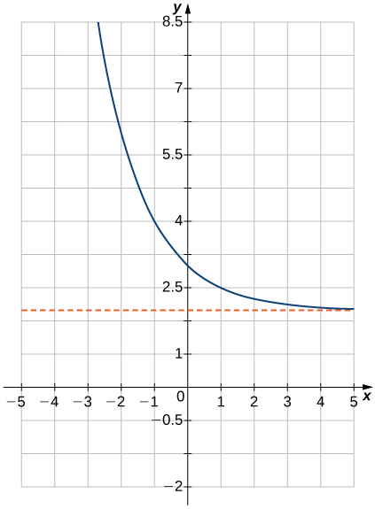

Answer: d

235.

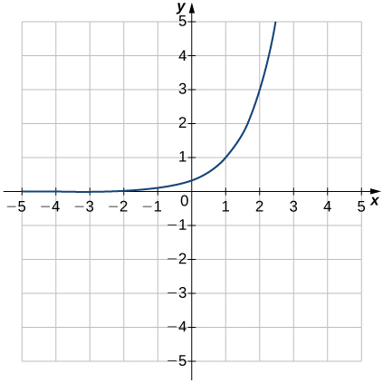

Answer: b

237.

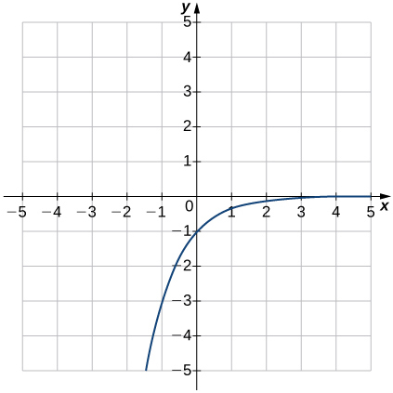

Answer: e

**For the following exercises, sketch the graph of the exponential function. Determine the domain, range, and horizontal asymptote.**

239. 

Answer: Domain: all real numbers, range: 

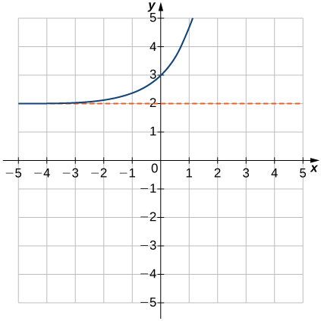

241. 

Answer: Domain: all real numbers, range: 

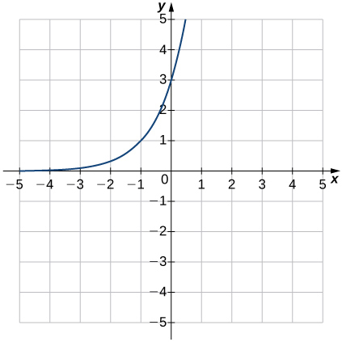

243. 

Answer: Domain: all real numbers, range: 

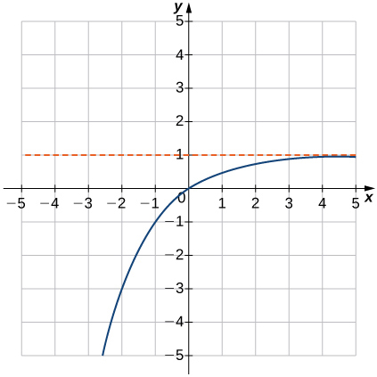

245. 

Answer: Domain: all real numbers, range: 

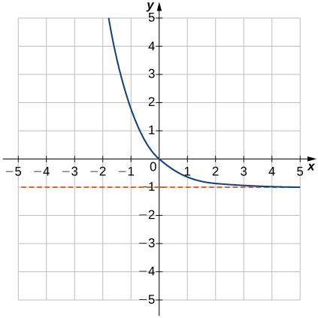

**For the following exercises, write the equation in equivalent exponential form.**

247. 

Answer: 

249. 

Answer: 

251. 

Answer: 

253. 

Answer: 

**For the following exercises, write the equation in equivalent logarithmic form.**

255. 

Answer: 

257. 

Answer: 

259. 

Answer: 

261. 

Answer: 

263. 

Answer: 

**For the following exercises, sketch the graph of the logarithmic function. Determine the domain, range, and vertical asymptote.**

265. 

Answer: Domain: , range: , 

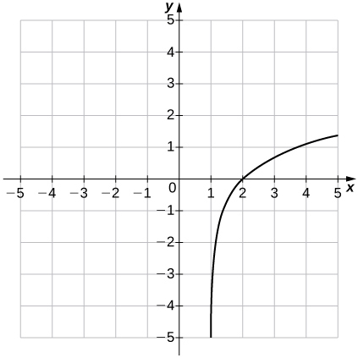

267. 

Answer: Domain: , range: , 

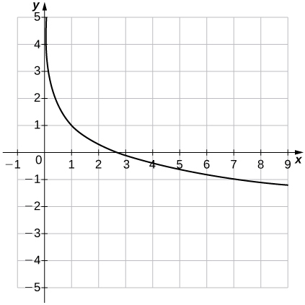

269. 

Answer: Domain: , range: , 

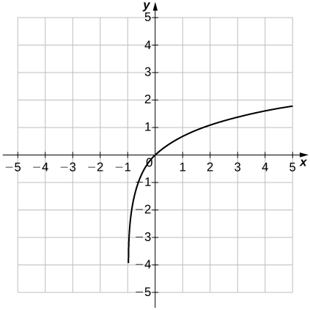

**For the following exercises, use properties of logarithms to write the expressions as a sum, difference, and/or product of logarithms.**

271. 

Answer: 

273. 

Answer: 

275. 

Answer: 

**For the following exercises, solve the exponential equation exactly.**

277. 

Answer: 

279. 

Answer: 

281. 

Answer: 

283. 

Answer: 

**For the following exercises, solve the logarithmic equation exactly, if possible.**

285. 

Answer: 

287. 

Answer: 

289. 

Answer: 

291. 

Answer: 

**For the following exercises, use the change-of-base formula and either base 10 or base *e* to evaluate the given expressions. Answer in exact form and in approximate form, rounding to four decimal places.**

293. 

Answer: 

295. 

Answer: 

297. 

Answer: 

299. **[T]** The number of bacteria *N* in a culture after *t* days can be modeled by the function . Find the number of bacteria present after 15 days.

Answer: 

301. **[T]** The amount *A* of a $100,000 investment paying continuously and compounded for *t* years is given by . Find the amount *A* accumulated in 5 years.

Answer: Approximately $131,653 is accumulated in 5 years.

303. **[T]** The concentration of hydrogen ions in a substance is denoted by , measured in moles per liter. The pH of a substance is defined by the logarithmic function . This function is used to measure the acidity of a substance. The pH of water is 7. A substance with a pH less than 7 is an acid, whereas one that has a pH of more than 7 is a base.

1. Find the pH of the following substances. Round answers to one digit.
2. Determine whether the substance is an acid or a base.
3. Eggs:  mol/L
4. Beer:  mol/L
5. Tomato Juice:  mol/L

Answer: i. a. pH = 8 b. Base ii. a. pH = 3 b. Acid iii. a. pH = 4 b. Acid

305. **[T]** According to the World Bank, at the end of 2013 () the U.S. population was 316 million and was increasing according to the following model:



where *P* is measured in millions of people and *t* is measured in years after 2013.

1. Based on this model, what will be the population of the United States in 2020?
2. Determine when the U.S. population will be twice what it is in 2013.

Answer: a. million b. 94 years from 2013, or in 2107

307. **[T]** A bacterial colony grown in a lab is known to double in number in 12 hours. Suppose, initially, there are 1000 bacteria present.

1. Use the exponential function  to determine the value , which is the growth rate of the bacteria. Round to four decimal places.
2. Determine approximately how long it takes for 200,000 bacteria to grow.

Answer: a.  b.  hours

309. **[T]** The 1906 earthquake in San Francisco had a magnitude of 8.3 on the Richter scale. At the same time, in Japan, an earthquake with magnitude 4.9 caused only minor damage. Approximately how much more energy was released by the San Francisco earthquake than by the Japanese earthquake?

Answer: The San Francisco earthquake had times more energy than the Japan earthquake.

**Chapter Review Exercises**

***True or False*? Justify your answer with a proof or a counterexample.**

311.  assuming *f* and *g* are functions.

Answer: False

313. A relation passing the horizontal line test is a function.

Answer: False

**For the following problems, state the domain and range of the given functions:**



315. *G*

Answer: Domain:  range: all real numbers

317. 

Answer: Domain:  and  range: all real numbers

**Find the degree, *y*-intercept, and zeros for the following polynomial functions**.

319. 

Answer: Degree of 3, -intercept: 0, zeros: 0,, 

**Simplify the following trigonometric expressions.**

321. 

Answer: or

**Solve the following trigonometric equations on the interval exactly.**

323. 

Anwer: 

**Solve the following logarithmic equations.**

325. 

Answer: 4

**Are the following functions one-to-one over their domain of existence? Does the function have an inverse? If so, find the inverse  of the function. Justify your answer.**

327. 

Answer: One-to-one; yes, the function has an inverse; inverse: 

**For the following problems, determine the largest domain on which the function is one-to-one and find the inverse on that domain.**

329. 

Answer: ,

**For the following problems, consider a restaurant owner who wants to sell T-shirts advertising his brand. He recalls that there is a fixed cost and variable cost, although he does not remember the values. He does know that the T-shirt printing company charges $440 for 20 shirts and $1000 for 100 shirts.**

331. a. Find the equation that describes the total cost as a function of number of shirts and b. determine how many shirts he must sell to break even if he sells the shirts for $10 each.

Answer: a. b. 100 shirts

**For the following problems, consider the population of Ocean City, New Jersey, which is cyclical by season.**

333. The population can be modeled by , whereis time in months represents January 1) and is population (in thousands). During a year, in what intervals is the population less than 20,000? During what intervals is the population more than 140,000?

Answer: The population is less than 20,000 from December 8 through January 23 and more than 140,000 from May 29 through August 2

**For the following problems, consider radioactive dating. A human skeleton is found in an archeological dig. Carbon dating is implemented to determine how old the skeleton is by using the equation , where is the percentage of radiocarbon still present in the material, is the number of years passed, and is the decay rate of radiocarbon.**

335. If the skeleton is expected to be 2000 years old, what percentage of radiocarbon should be present?

Answer: 78.51%

This file is copyright 2016, Rice University. All Rights Reserved.